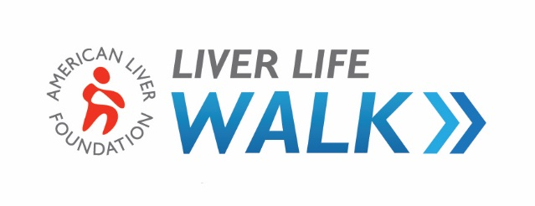

TEAM CAPTAIN GOAL SETTING WORKSHEET

Team Name:

Captain:

Co-Captains:

When setting your team’s goals, look back at your team’s performance from last year (if applicable). The average walker raises $100. The average team captain raises $253.

PREVIOUS YEAR’S RESULTS (ALF Staff can provide the below information if requested) | THIS YEAR’S GOALS
# of team members: | # of team members:  (i.e.: 20% increase = number of previous year walkers x 1.2)
$ amount raised: $ | Minimum $ goal: $  (i.e.: team member goal x previous team member average)
Average team member $ raised: $  (Dollars raised ÷ number of team members) | Suggested $ goal: $  (i.e.: number of team members goal x $100 walker average)

2020 PLANNING ACTIVITIES
- Appoint team co-captains

Due date:
People to ask:

•
•
•
- Customize team web page (visit your MY HQ)

Due date:

- Recruitment activities

ACTIVITY | DATE | $ GOAL

- Fundraising activities

  - Announce via email and/or social media your team has been created. Include all previous team members and/or company employees
ACTIVITY | DATE | $ GOAL

Due date:

    - Email to all team members announcing goals and activities

Due date:

    - Thank you note to all team members

Due date:

RECRUITMENT CHECKLIST
- I have set my team recruitment goal (if I am a returning team captain, my goal is at least
20% higher than my previous year’s team size).
- I have selected my co-captain(s) and a team committee to assist me in organizing and motivating my team.
- If I have a corporate team, I have secured support from my company’s top executives.
- I have set a date for our recruitment event and asked the ALF to send a representative to my event.
- I have publicized my team through posters, newsletters, social media and word of mouth.
- I have personalized my email signature to let others know I am riding and recruiting team members.
- I have made a list of possible team members and personally asked each individual to join my team.
- I have encouraged every team member to recruit at least one new team member to join our team.
- I have contacted the ALF for help brainstorming other ideas.
FUNDRAISING CHECKLIST
- I have set a team goal and have informed all of my team members of our team fundraising goal.
- I have personalized my personal and team web page with a picture and short story of why we walk.
- I have familiarized myself with the fundraising resources available on liverlifewalk.org.
- I have asked my company or organization to make a donation to our team.
- I have asked my team members and donors if their companies have a matching gift program. If so, I have encouraged them to ask their coworkers to donate to them and request matching funds.
- I have planned at least one fundraising event for my team (e.g. bake sale, car wash, etc.).
- I have told everyone on my team the date of our fundraising event and delegated responsibilities to them.
- I have informed the ALF of our fundraising event.

